# PDF Sweeping

## November 2018

### Description:

We sweep the previous day’s created communications to a series of files so the clients can do fulfillment. In this delivery, we provide:

1. A manifest (either Excel or text)
2. A zipped file of pdfs that match the manifest

### Clients:

* Meridian (PMD environment only)
  + Files are dropped to \\sqlrdp\ClientFiles\Meridian\Outbound\Reports
* HealthspringSaas (HS environment only). They are then sent to the PharmMD SFTP server.
  + Files are dropped to \\sqlrdp\ClientFiles\HealthspringSaaS\Outbound\Reports
* SCAN (SCAN environment only). They are then sent to the PharmMD SFTP server.
  + Files will EVENTUALLY be dropped to \\sqlrdp\ClientFiles\SCAN\Outbound\Reports but are currently sent to the PharmMD SFTP server and then sent to the client’s SFTP

There is a separate job for each of these on SQLETL in the SQL Server Agent. They are set to retry up to 2 times (3 total) before sending a failure notice out. The job below without the red “x” on them are the currently enabled jobs.

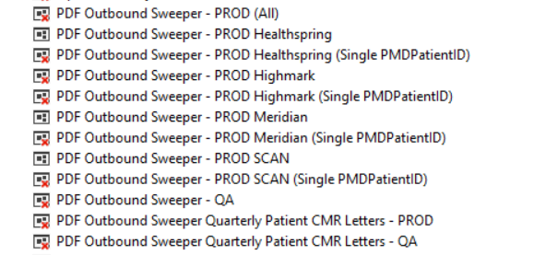

**Sample Failure Email:**

